Automorph EQ VST
Manual for Windows by aquanode (2026)

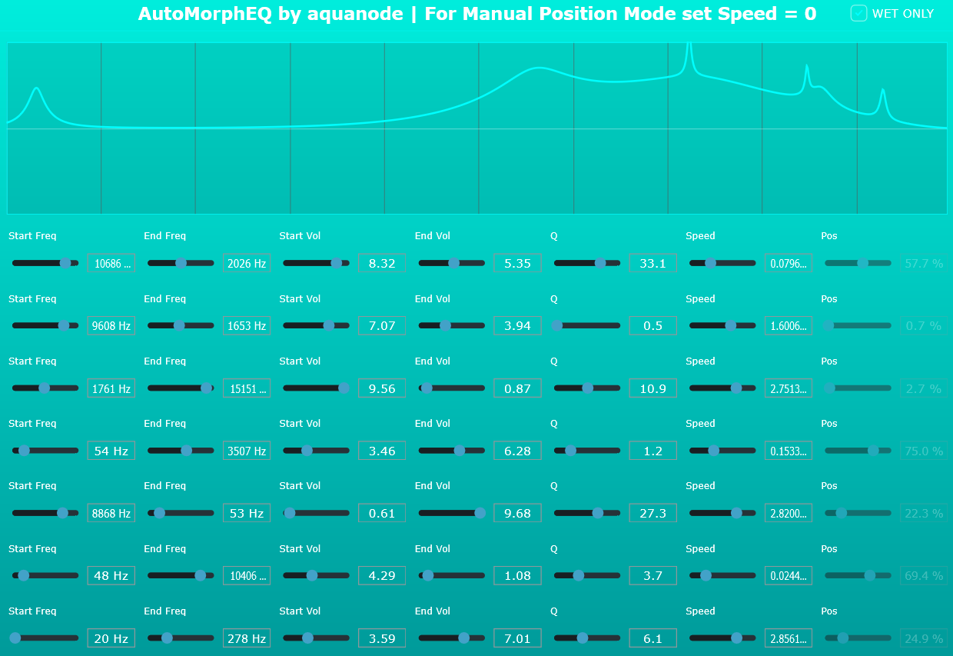

Personal / Copyright Message: This plugin is a passion project for the community.
It is completely free and open source!
Feel free to use it in your own projects, modify the source code and whatever.
You may use the code and setup in your own paid projects, but you may not simply re-upload my plugin and charge money for it unaltered.
Thank you for your interest in my 4th VST plugin, which I built with JUCE/Visual Code C++.

“AutoMorphEQ” is, as the name suggests, a morphing equalizer where you can specify start and endpoints of a bell filter, and the speed at which it oscillates between these points.

I highly recommend using FL Studio with this plugin, as FL Studio can Randomize all parameters at once to create interesting results you usually would not manually create.

It is a VST equivalent of some earlier filter effects I created in FL Studio’s Patcher for example, that are also free to download on aquanode.gumroad.com.

How to install
Next to the .vst3 and this pdf, you will find 4 files with endings .h and .cpp in this folder. These make up the complete source code for JUCE, so you can compile and remake the whole effect plugin yourself if you like. Otherwise, you don’t need them.

As I do not own a Mac, only PC / Windows is supported. The plugin was tested on Windows 11 22H2, FL Studio 25, Ableton Live 11, and using Tracktion’s pluginval.
  - Download the zip file and extract it (you did this already).
  - Copy the whole .vst3 folder into your system's VST3 folder. Usually, this is:
C:\Program Files\Common Files\VST3 or subfolders in here.
  - Rescan your DAW’s plugin library (FL Studio, Ableton Live, etc.). The plugin should appear under the "Effects" or "EQ" category.
  - Add it to a mixer track, to which sound is routed.

explanations of the controls

  - Start Frequency: Frequency where the filter starts its sweep.
  - End Frequency: Frequency where the filter ends its sweep.
  - Start Volume: Volume at which the filter starts its sweep.
  - End Volume: Volume at which the filter ends its sweep.
  - Q: Width of the respective filter.
  - Speed: Speed at which the filter oscillates between start & end.
  - Position: If speed is = 0 (refreshed), you can manually position the filter.
  - Wet Only: Cancels the original sound (Button on the top right).
Many thanks to Google for their Gemini AI that was indispensable for me to grasp how JUCE and C++ programming even works. It was a real time-saver, as I did not need to become an expert in all the details. The downside to that is of course that I’d still not be able to program a plugin without its help. Fonts used in this Documentation: Aquatico, Bahnschrift, Conthrax.

